Instructions to Session Chairs/Organizers
ICADL 2021

General
- You have total control of your session(s).
- The conference organizer will set a “Session Support” staff for each session. Session Support will set up the Zoom meeting room for you and provide technical support (e.g. play paper videos, handle unexpected technical issues) throughout your session.
- Please come to the session room at least 10min before the session start.
- You should keep connected using Zoom, which is the main platform for ICADL 2021.
- The conference organizer will announce general information through email. To ensure the security of conference sessions, passwords for Zoom meetings will be sent to you ONE DAY before the conference.
- You can access all conference sessions through the links posted on the conference program section at ICADL2021 page: https://icadl.net/icadl2021/index.html#Program
- If you need any support, please contact us at: icadl2021-chairs@ml.cc.tsukuba.ac.jp
- “5-MINUTE RULE”: if you encounter any unexpected technical issues, log back into the same zoom room in 5 MINUTES. We will not make any special and additional announcements.

Downloading and getting familiar with Zoom
- Please download Zoom from www.zoom.us/download#client_4meeting
- More Zoom training videos: https://support.zoom.us/hc/en-us/articles/206618765-Zoom-video-tutorials
- Zoom privacy and security information: https://zoom.us/docs/en-us/privacy-and-security.html

Managing a meeting
- You can join a meeting by using the Meeting ID and Password, as shown in Figs. 1-4. Please use your real name for the meeting.
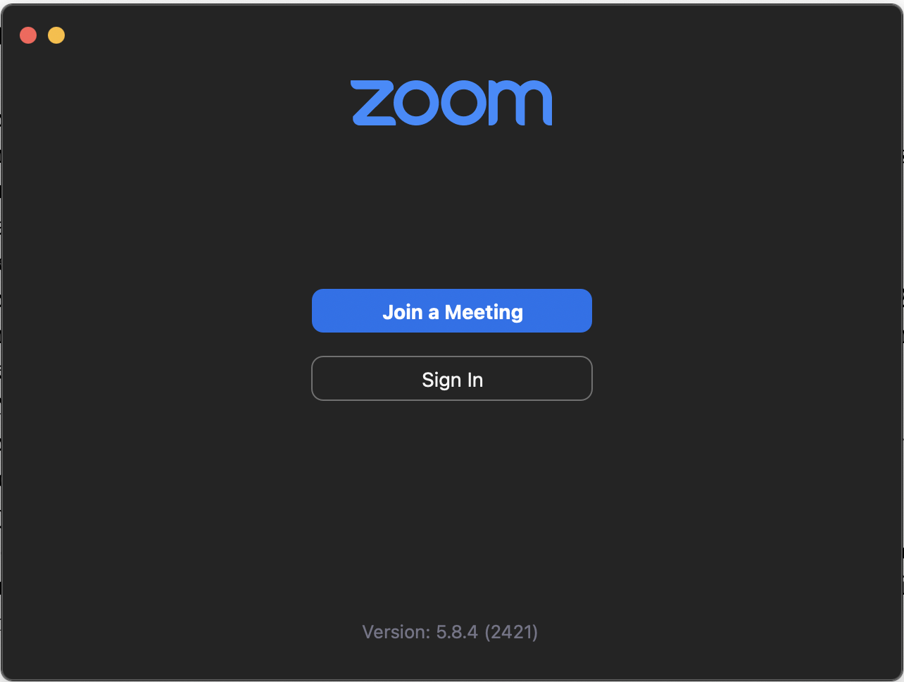
Fig.1 Zoom page for joining a meeting
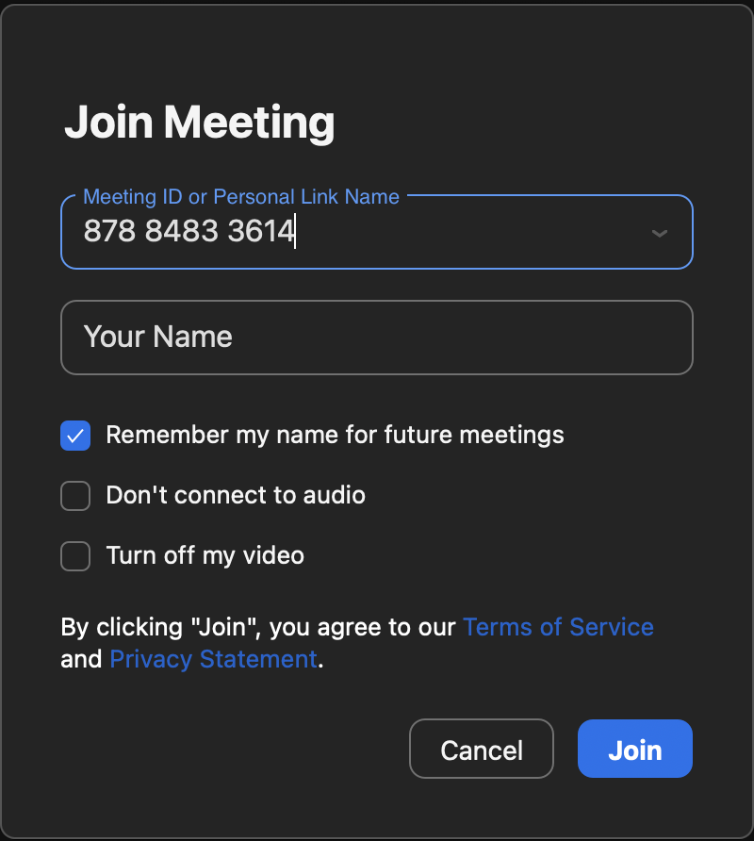
Fig.2 Join a meeting with Meeting ID

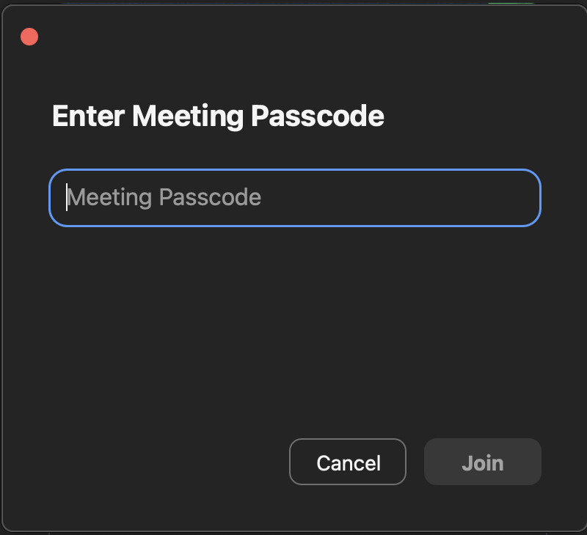
Fig.3 Enter meeting passcode

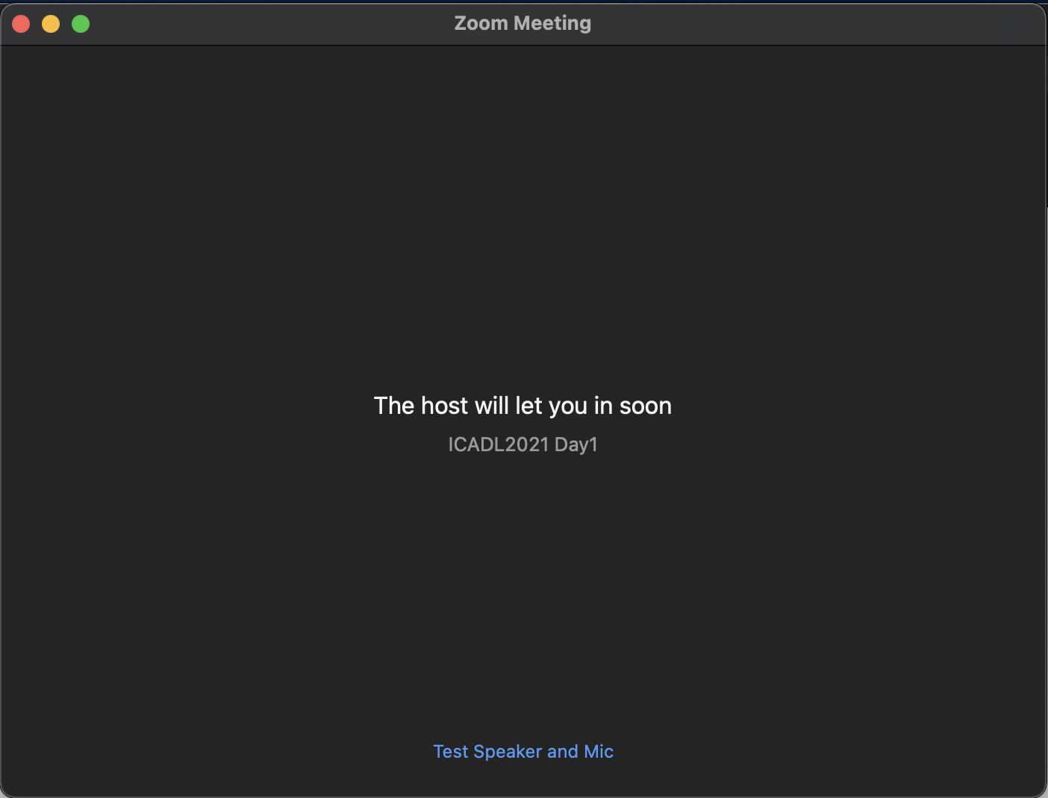
Fig.4 The waiting room page before being admitted to the meeting

- As a session chair, you will be assigned as the co-host of the session. The Session Support staff will be the host to assist you.
- If you are not familiar with the control of a Zoom meeting, please watch this video: https://www.youtube.com/embed/ygZ96J_z4AY?rel=0&autoplay=1&cc_load_policy=1
- If you want to know more about how to keep uninvited guests out of the Zoom room, please watch: https://blog.zoom.us/keep-uninvited-guests-out-of-your-zoom-event/
- Best practices for securing Zoom meetings can be found here: https://zoom.us/docs/doc/Securing%20Your%20Zoom%20Meetings.pdf

